EVENT: SSS Women’s team racing championships

DATE: 3rd-4th of November 2018 SAILING INSTRUCTIONS

1 Rules
  - Racing will be governed by the rules as defined in the Racing Rules of Sailing (RRS) including Appendix D, Team Racing Rules.
  - Addenda A, B and C to these sailing instructions (SIs) always apply. Other addenda apply only when so stated. The letters D and I are not used to identify addenda.
  - The right of appeal is denied in accordance with RRS 70.5(a).
  - When boats are provided by the Organising Authority they shall be deemed to conform to their class rules. When class rules change RRS 42, such changes shall not apply.

Eligibility
  - To become eligible a team shall register as required by the notice of race or, if not specified, on arrival at the event. The team shall provide any required damage deposit before going afloat for the first time.
  - After registration, no team member may be changed without the prior permission of the race committee which will be given only in exceptional circumstances.

Event Format and Schedule of Races
  - The intended format of the event is described in SI Addendum B. The format may be modified during the event in a fair and practical way as solely determined by the race committee taking into account the entries, weather conditions, time constraints and any other relevant factors.
  - The initial schedule of races will be displayed on the official notice board. Any changes thereto and schedules for subsequent rounds will be displayed not less than 10 minutes before the start of that phase of the competition.
  - Every race will be assigned a race number in the race schedule.
  - The number of the next race to start will be displayed on the committee boat no later than the warning signal (or promptly thereafter if co-incident with the previous start) until the starting signal. The race committee may at any time postpone a race and reschedule it at a later time.
  - When the race or protest committee orders a resail of a completed race, the race committee may postpone the resail indefinitely and score each team half a race win unless the result is relevant to progress, but not seeding, in the next round.

Protests, Requests for Redress and Penalties

Protests and requests for redress that have not been decided afloat shall be notified to the race office within 10 minutes after the relevant incident or, if the incident is afloat, within 10 minutes after coming ashore.

When the outcome of a protest or request for redress would not affect which teams qualify to a later stage, the protest committee may refuse to hear it. This amends RRS 63.1.

When RRS D2 applies and the race umpires together with one other umpire (when available) decide that a boat has broken RRS 14 and there is damage or injury, they may penalise her team by half a race win without a hearing. The boat will be informed as soon as practical and may request a hearing. Any penalty after a hearing will be in accordance with RRS D3.1(d). This amends RRS 63.1.

When the race committee decides that a boat has broken SI A4.3, Time Limit for Starting, or has failed to sail the course and broken RRS 28.2, it shall penalise her 6 points without a hearing. This amends RRS A5.

When the race committee decides that a competitor has broken SI A1.5, personal flotation device, or SI A1.6, wet or dry suits, it shall penalise the competitor’s team one race win without a hearing. This amends RRS A5.

When the protest committee decides that a breach of a rule, other than a rule of RRS Part 2, has had no effect on the outcome of a race, it may make any arrangement it decides is equitable, which may be to impose no penalty. This amends RRS 64.1 and D3.1.

Risk Statement, Insurance
  - Rule 4 of the Racing Rules of Sailing states: "The responsibility for a boat’s decision to participate in a race or to continue racing is hers alone."
Sailing is by its nature an unpredictable sport and therefore inherently involves an element of risk. By taking part in the event, each competitor agrees and acknowledges that:
(a) They are aware of the inherent element of risk involved in the sport and accept responsibility for the exposure of themselves, their crew and their boat to such inherent risk whilst taking part in the event;
(b) They are responsible for the safety of themselves, their crew, their boat and their other property whether afloat or ashore;
(c) They accept responsibility for any injury, damage or loss to the extent caused by their own actions or omissions;
(d) Their boat is in good order, equipped to sail in the event and they are fit to participate;
(e) The provision of a race management team, patrol boats and other officials and volunteers by the event organiser does not relieve them of their own responsibilities;

(f) The provision of patrol boat cover is limited to such assistance, particularly in extreme weather conditions, as can be practically provided in the circumstances.

(g) It is their responsibility to familiarise themselves with any risks specific to this venue or this event drawn to their attention in any rules and information produced for the venue or event and to attend any safety briefing held for the event
  - When the boats are provided by the competitors, the boat is required to hold adequate insurance and in particular to hold insurance against third party claims in the sum of at least three million pounds (£3,000,000), unless a different sum is specified in the notice of race.

Index to SI Addenda
Not all addenda will apply to every event; see SIs 1.2 and A5.1.

Addenda That Always Apply
A Event Related Rules
B Event Format
C Courses
Race Formats and Schedules
D Round-Robins in Groups, Schedules and Tie Breaks
Other Addenda
E When Boats are Supplied by the Organising Authority

Addendum A
Event Related Rules

Event:

Section 1: Additional Rules

A1.1 RRS D2 applies. Races will be umpired. | Yes
A1.2 RRS D1.1(d) is deleted. No Arm Signals are required. | Yes
A1.3 (1) A boat capsized after her starting signal, so that her masthead is in the water, shall retire promptly.  OR  (2) A boat capsized after her starting signal, so that both her gunwales are touching the water or her mast is stuck in the bottom, shall retire promptly. | 1
A1.4 Provided the flag remains on the buoy there shall be no penalty when a boat touches any part of a flag which does not surround the staff of a mark. This amends RRS 44.1. | No
A1.5 An adequate personal flotation device shall be worn at all times whilst afloat. | Yes
A1.6 Wet or dry suits shall be worn at all times when afloat. | Yes

Section 2: Communications with Competitors
A2.1 Notices to Competitors
Notices to competitors will be posted on the official notice board located in the clubhouse used for the event.

A2.2 Changes to Sailing Instructions
Changes to these SIs will be signalled by flying flag L from Club flagpole. Such changes will be posted on the official notice board not less than 10 minutes before the warning signal of the first affected race.

A2.3 Signals Made Ashore
Signals made ashore will be displayed on the Club flagpole.

Section 3: Courses, Marks, Starting & Finishing Lines, Obstructions and Time Limits
A3.1 Racing Area
The racing area will be Oban Bay, with the location of the course defined at the morning briefing.

A3.2 Course
The course will be course inverted S as described in SI Addendum C.

A3.3 Marks
The marks of the course will be yellow drop buoys unless otherwise stated in the morning briefing.

A3.4 Moving Marks
The race committee may move marks of the course at any time. RRS 33 will not apply.

A3.5 Obstructions
The following area is defined as an obstruction: Sgeir Rathaid (The Scrat, between the north and south cardinal marks in the middle of the bay).

A3.6 Starting Line
The starting line will be between the mast of a committee boat and a starting mark.

A3.7 Finishing Line
The finishing line will be between the mast of a committee boat and a finishing mark.

A3.8 Time Limits
The time limit for each race shall be 10 minutes.

Boats that fail to finish within 10 minutes after the first boat finishes will be scored DNF. This amends RRS 35 and A5.

Section 4: Starting Procedure
A4.1 Starting Signals
Races will be started by using the signals and timing selected in the following table. Times shall be taken from the start of each sound signal; the failure of a visual signal shall be disregarded. This amends RRS 26.

Event System
Signal | Timing options | Signals
 | Minutes before starting signal | Sound | Battens or orange cylinders
Warning | 3 | One | 3 displayed
Preparatory | 2 | One | 2 displayed
One-minute | 1 | One | 1 displayed
Starting | 0 | One | None or  3 displayed

Attention may be drawn to an imminent warning signal by a series of short sound signals.

A4.2 Recall Signals
When a boat is subject to RRS 29.1, flag X need not be displayed for more than 1 minute after the starting signal; this amends RRS 29.1. The race committee may hail the sail numbers or the total number of premature starters.

A4.3 Time Limit for Starting
A boat that fails to start within three minutes of her starting signal will be scored DNS without a hearing. However, if the boat was OCS at her starting signal, she shall be scored in accordance with RRS D3.1(b). This amends RRS A4 and A5.

A4.4 General Recall
After a general recall, succeeding races may be delayed for the recalled race. Attention is drawn to SI 3.4.

Section 5: Local and Other Rules
A5.1 rules in SI addenda
The rules in the following SI addenda apply throughout the event:

Addendum K | When Boats are Supplied by the Organising Authority | Yes
Addendum L | Boat Handling Rules | Yes

Addendum B
Event Format

The format for each stage of the event shall be selected from the following standard formats, or from an Addendum J provided by the race committee and included with these sailing instructions. The specified addendum for each format contains the necessary race schedules, or procedures to create the schedules, together with rules which shall apply for scoring and breaking ties.

Each stage of an event may use a different format. The race committee may change the format as provided in SI 3.1.

Code | Description | Format Rules
Groups | Round-robin(s) in groups | RRS D4
Random | Random pairs (2-boat teams only) | Addendum F
Swiss | Swiss league | Addendum G
HLS | HLS league | Addendum H
RC | Other format provided by race committee | Addendum J
KO | Knock-out | RRS D4

For a stage in Groups, any change to the percentage in RRS D4.2(b) shall be stated.

When the format includes a Knock-Out stage, the method of qualification for the Knock-Out stage shall be stated.

For a Knock-Out stage, the number of race wins required to win a match shall be stated, as RRS D4.6. However, if not stated the winner shall be the first team to score two race wins.

The intended format is

Stage | Format Code | Additional Rules
1 | RRS D4 | Round robin
2 | RRS D4 | Round Robin in gold and silver leagues
3 | RRS D4 | Knock outs

Addendum C
Courses

C1 Inverted 'S' Course
This is the standard team racing course for multi-team dinghy events.
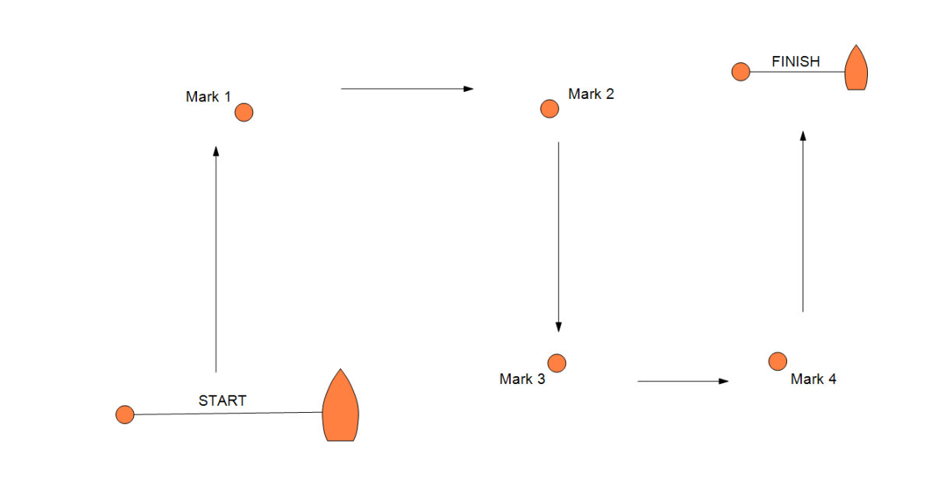
Start, round marks 1 then 2 to starboard, round marks 3 then 4 to port, Finish

Addendum D
Round Robins in Groups

E1 In a round-robin stage, teams are assigned to one or more groups and scheduled to sail against all other teams in their group one or more times.

E2 The stage shall be scored in accordance with RRS D4.1 to D4.5 inclusive.

E3 Using the seeding from the first round robin, teams will be grouped in to two groups based on their seeding. Top ranked teams will be seeded in to gold league and will sail a round robin within this league, with the same occurring for the silver league, containing the lower half of the seeded teams.

E4 If time allows, there will then be knock outs within the leagues to determine an overall winner.

Addendum E
When Boats are supplied by the Organising Authority

J1 For each race, the race committee will allocate boats to the participating teams.

J2 Spinnakers, trapezes and the gear specifically provided for the utilisation of these shall not be used, unless permitted in the sailing instructions.

J3 Standing rigging shall not be altered nor any gear removed without the permission of the race committee.

J4 BREAKDOWNS
        - When a supplied boat suffers a breakdown, RRS D5 applies.
        - Competitors are responsible for inspecting their boats before racing.
        - Competitors shall report any defects, damage or breakdown to the race committee at the first reasonable opportunity.
        - When to continue racing after damage a breakdown risks further damage to the boat, she shall retire immediately.

J5 CONTINUITY
- Before starting and after finishing or retiring, boats shall sail to minimise any delay to the race schedule and without interfering with any race in progress.
- A boat shall remain the responsibility of the team until handed over to the race committee or the next team to use that boat. Boats shall be handed over as empty of water as practical and in racing trim.

In this document the word 'stage' is used (instead of round) for each major section of an event.

